Filter by text
Locators can be filtered by text with the new Locator.FilterOptions().setHasText("SpecificText"). It will search for a particular string somewhere inside the element, possibly in a descendant element, case-insensitively. You can also pass a regular expression.
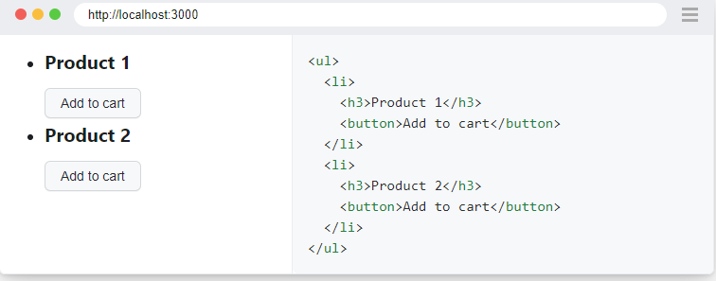
Filter by not having text
new Locator.FilterOptions().setHasNotText("SpecificText"))
Filter by child/descendant
Filter by not having child/descendant

